**Instructions for Using Clinic Visit Record (CVR) Data to Obtain Monthly Percentages of Unduplicated Female Clients, Aged 15-24, Who Were Tested for Chlamydia**

Unduplicated client counts of females, aged 15-24, who were ***newly* tested** for Chlamydia **each month** are readily available based on Clinic Visit Record (CVR) data summarized in the “Build A Report” function on the Ahlers website. Obtaining this information will require several simple steps to isolate the number of female clients *newly* tested and served in any given month from those tested and served in any of the previous months of the year. Baseline data for this project will begin with female clients *newly* served and tested in May 2018, and will require the following:

* First, you will need to capture and record thetotal unduplicated female clients ***served*** **for the year to date (YTD)** for **April 2018**, and aggregate across smaller age groups.
* Second, you will need to capture and record the **total** of unduplicated female clients ***tested*****for the year to date** **(YTD)** for **April 2018**, and aggregate across smaller age groups.
* Next, you will need to follow the same two steps above for **May 2018** and then for each **subsequent month** **of interest for the duration of the project in 2018**. To obtain the YTD running total for each of the months January through March of 2019, you will need to enter the first day of the new year, i.e., 1/1/2019 for the “From Date,” which will in effect restart the YTD running totals of unduplicated clients tested and served.
* Once you have these unduplicated YTD totals, you will need to subtract the **YTD *served*** and ***tested*** running totals for each month (beginning with April 2018) from the corresponding running totals for the subsequent **month of interest** (beginning with May 2018).
* The remaining numbers reflect the female clients ***uniquely* served and tested** during the **month of interest** and can be used to calculate the percentage tested for that month.

**\*\*\* Note: an Excel table is provided for your convenience to use as a data collection and calculation tool. \*\*\***

Following are explicit instructions for obtaining this information:

1. Go to the Ahlers website (<http://ahlerssoftware.com/>).
2. Click on client login (in the middle of the page).
3. Enter your User ID and Password, and then click “Log In”. Select “Build A Report” from the available remote services listed on the left-hand side of the page (it is the second option from the top).

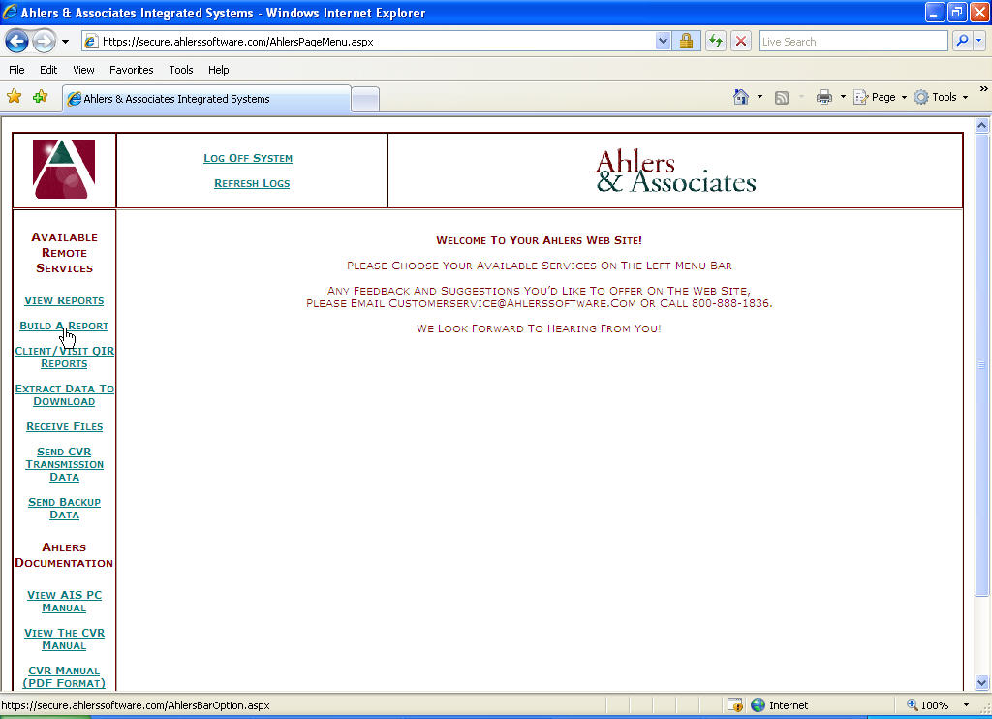

1. On the first Build A Report screen, choose your agency from the “Select an Agency” drop-down menu (unless it is already defaulted to your agency). If appropriate, please select the one main SITE that you will be working with for the Chlamydia Screening Performance Improvement Collaborative. Details for selecting the Time Period follow in Step 5.

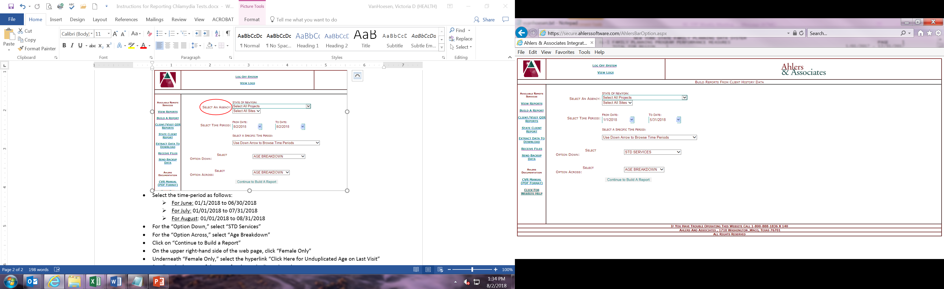

1. **To obtain the unduplicated female client count for May 2018 to start**:

First obtain the YTD total for April 2018, by entering ‘1/1/2018’ for the “From Date” and ‘4/30/2018’ for the “To Date” as shown above.

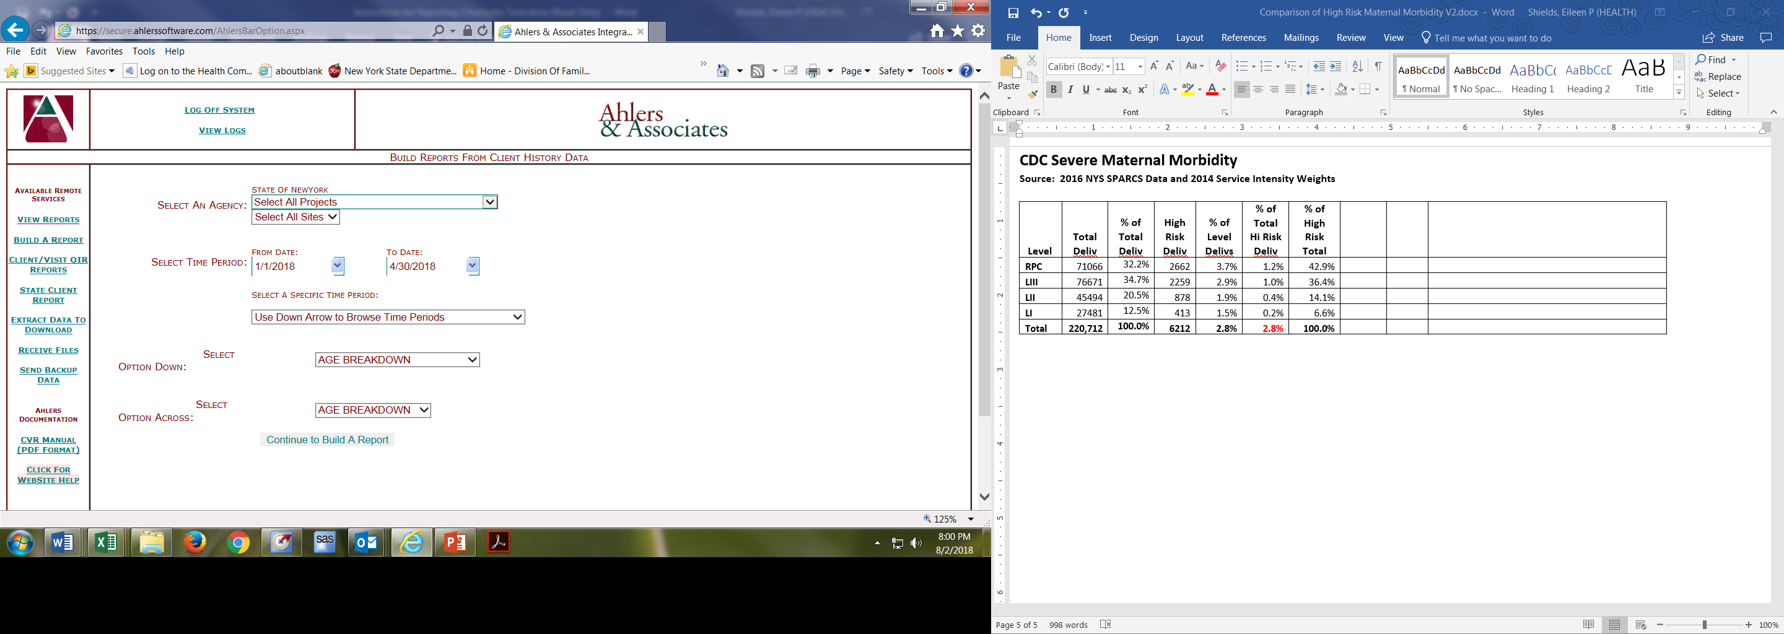

Then obtain the YTD total for May 2018, by entering ‘5/31/2018’ for the “To Date”.



To obtain, the **YTD total** for each of the months following May **through December**, you will need to enter the first day of the year, e.g., 1/1/2018, for the “From Date” and the last day of the month of interest for the “To Date.” To obtain the YTD running total for each of the months January through March of 2019, you will need to enter the first day of the new year, i.e., 1/1/2019 for the “From Date,” which will in effect restart the YTD running totals of unduplicated clients tested and served.

**\*\*\* Note: A table of monthly YTD running total periods is provided at the end of this document. \*\*\***

1. For the “Option Down,” select “STD Services.”

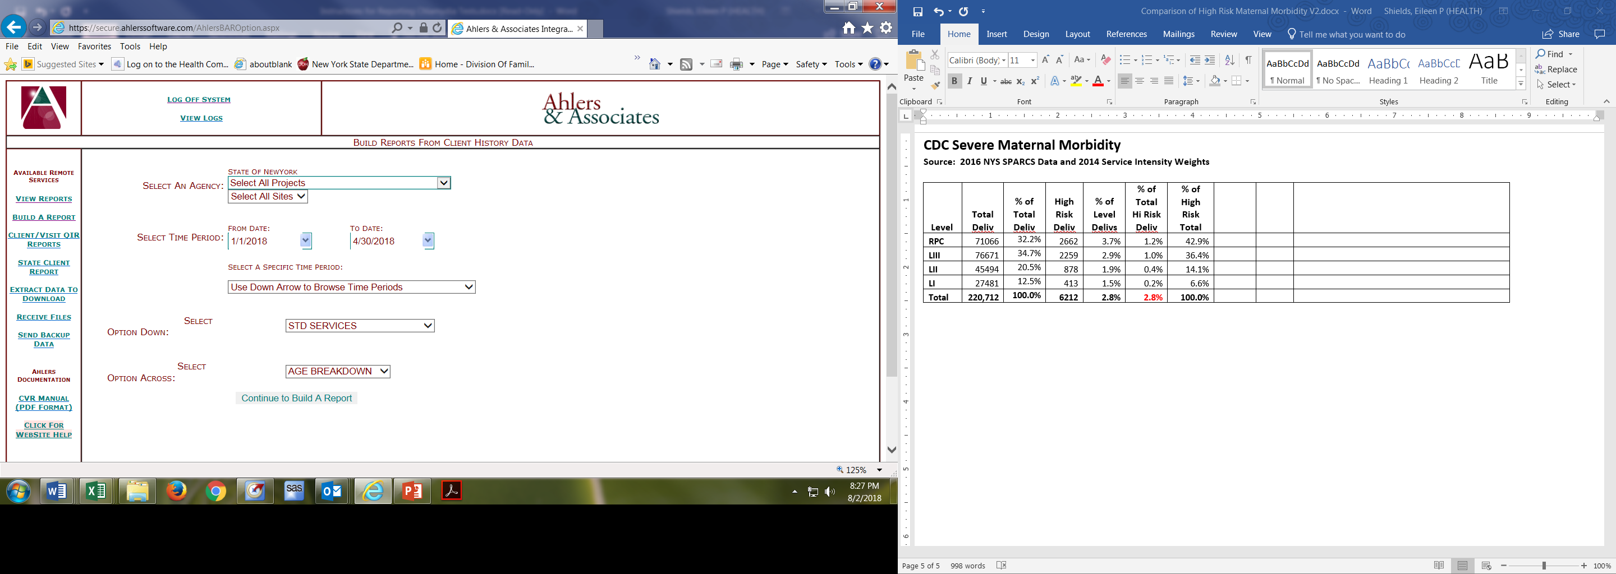

1. For the “Option Across,” select “Age Breakdown.”



1. Click on “Continue to Build a Report.”



1. Locate the selection options on the upper right-hand side of the next Build A Report web page.

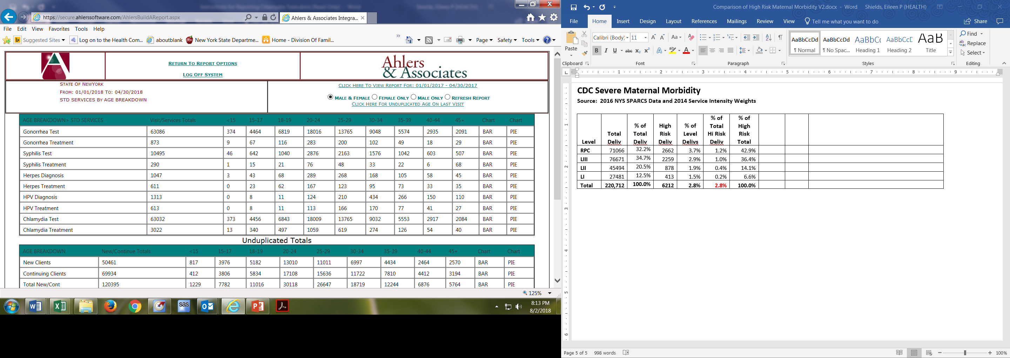

1. Click on “Female Only.”

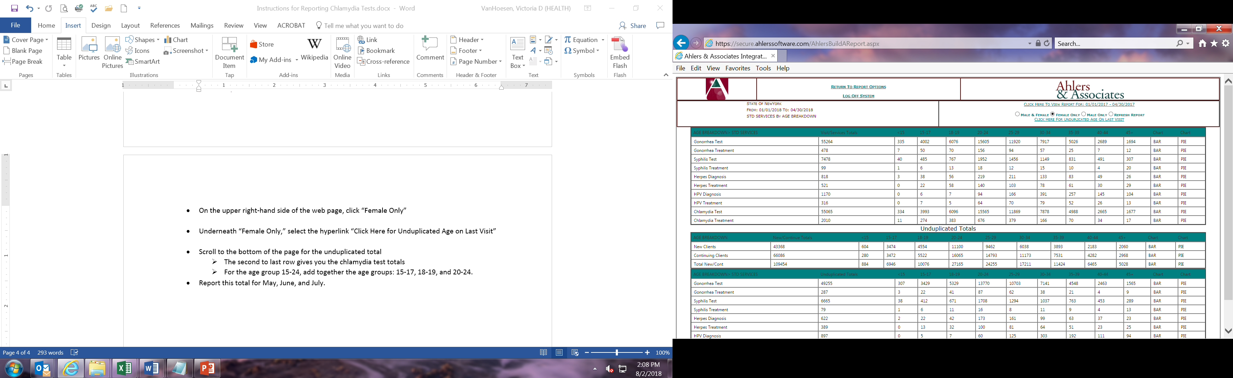

**Note: please be sure to select “FEMALE ONLY” each time you change the time-period.**

**DO NOT REQUEST UNDUPLICATED AGE ON LAST VISIT.**

1. Scroll to the bottom of the page to the “Unduplicated Totals” section (as shown on the next page).

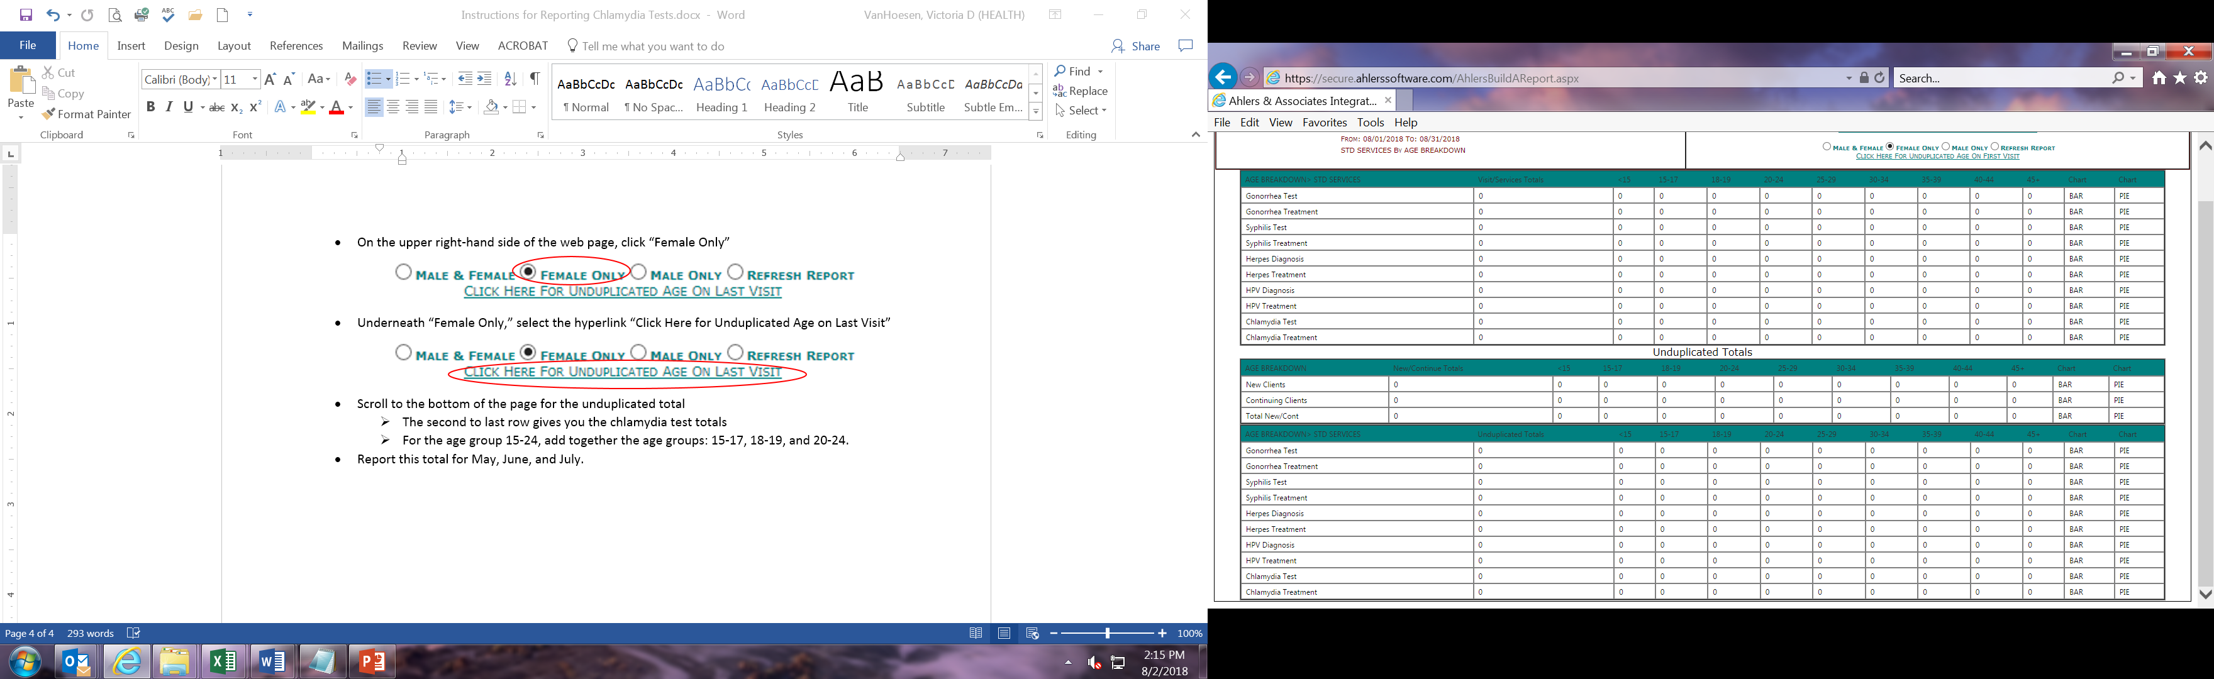

The third row provides the total number of unduplicated female clients **served YTD** by age group.

The second to last row provides the unduplicated number of female clients **tested** for Chlamydia YTD by age group.

1. To calculate the **total** **served YTD** and the **total tested YTD** for the age group 15-24, add together the corresponding counts for the smaller age groups: 15-17, 18-19, and 20-24.
2. Record both of these unduplicated **female** **client** **YTD totals** for the month specified in “To Date” **in the separately provided data collection tool depicted below**. (Please be sure to enter your agency, and participating site name if applicable, in the space provided in the table as well.)



**\*\*\* Note: when you record the client YTD totals for April 2018 and each of the subsequent project months in the provided Excel tool, the calculations described on the next page and detailed in the example for May 2018 will be automated for you. \*\*\***

Here is how the calculations are made in the table:

* Unduplicated counts of female clients aged 15-24 who were newly served and were newly tested for Chlamydia in the current month are isolated by subtracting the *previous* month’s unduplicated client YTD totals from the *current* month’s unduplicated client YTD totals.
* The monthly percentage of female clients aged 15-24 tested for Chlamydia is calculated by dividing the monthly unduplicated total tested by the monthly unduplicated total served.

**Detailed example of calculations for May 2018:**

To obtain the unduplicated client count of females aged 15-24 **served for May 2018 (A)**, subtract April’s (previous month) YTD total of client served for 1/1/2018 – 4/30/2018 from May’s (current month) YTD total of clients served for 1/1/2018 – 5/31/2018.

To obtain the unduplicated client count of females aged 15-24 **newly tested for Chlamydia for May 2018 (B),** subtract April’s (previous month) YTD total of clients tested for 1/1/2018 – 4/30/2018 from May’s (current month) YTD total of clients tested for 1/1/2018 – 5/31/2018.

Divide the count of clients tested (A) during May by the count of clients served during May (B) and multiply the result by 100 to get the **percentage** tested for Chlamydia during May.

Total female clients aged 15-24 **served** **YTD** 1/1/18 – 5/31/2018: 50

Total female clients aged 15-24 **served** **YTD** 1/1/18 – 4/30/2018: 35

Total female clients aged 15-24 **newly** **served** 5/1/2018-5/31/2018: 25

Total female clients aged 15=24 **tested** **YTD** 1/1/18 – 5/31/2018: 20

Total female clients aged 15-24 **served** **YTD** 1/1/18 – 4/30/2018: 10

Total female clients aged 15-24 **newly** **served** 5/1/2018-5/31/2018: 10

**Percentage** female clients **newly** **tested** 5/1/2018 – 5/31/18: 10 / 25 * 100 = 40.0%

1. To continue using Ahlers’ website, select “Return to Report Options” at the top of the screen.

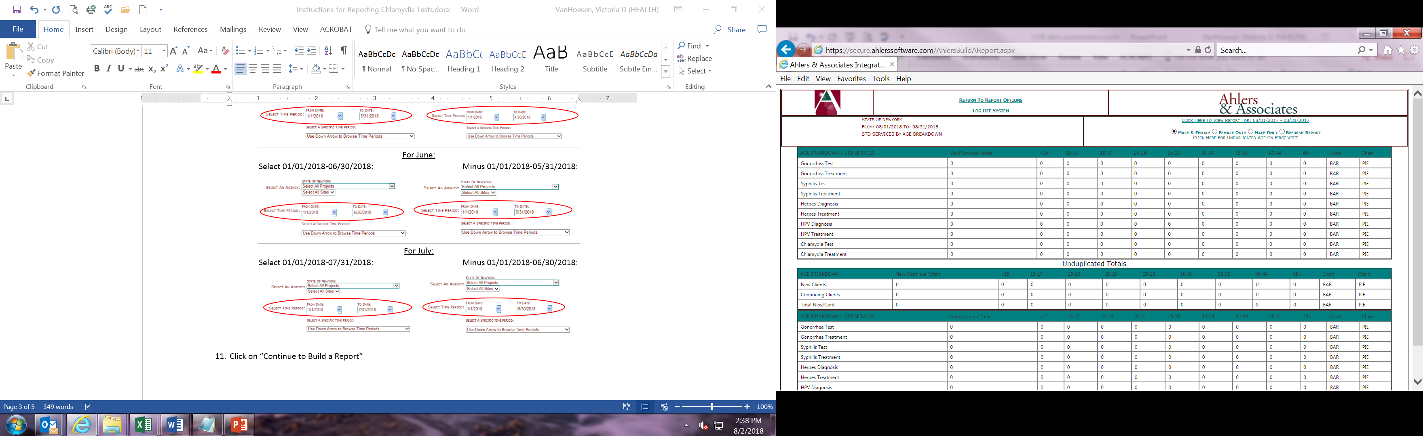

1. When you are finished, log off of Ahlers’ web site.

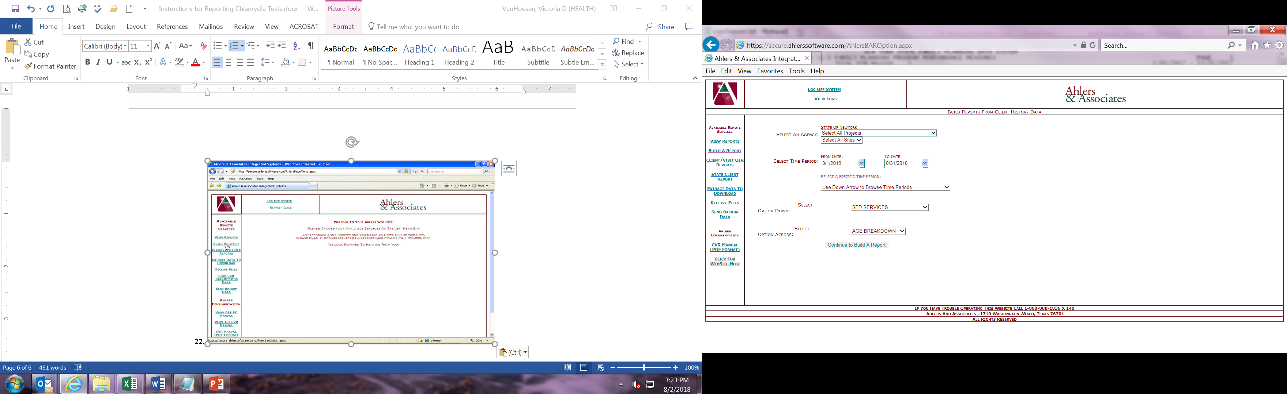

1. Save the data collection tool with your agency and site name (if applicable) along with the newly added and calculated data, and email it to:

**???????????**

**Note: Data submissions are due on the xxxxxxxxxx of each month.**

17. If you have any questions or difficulties, contact us at:

???????????

**WHERE SHOULD WE HAVE THEM SEND THE TABLES AND DIRECT QUESTIONS?**

**Table of Corresponding Previous and Current Months’ YTD Total Period Specifications**

|  |  |  |
| --- | --- | --- |
| **Month for Which Unduplicated Count Is Needed** | **Previous Month’s YTD Total Period** | **Current Month’s YTD Total Period** |
| May 2018 | 1/1/2018 – 4/30/2018 | 1/1/2018 – 5/31/2018 |
| June 2018 | 1/1/2018 – 5/31/2018 | 1/1/2018 – 6/30/2018 |
| July 2018 | 1/1/2018 – 6/30/2018 | 1/1/2018 – 7/31/2018 |
| August 2018 | 1/1/2018 – 7/31/2018 | 1/1/2018 – 8/31/2018 |
| September 2018 | 1/1/2018 – 8/31/2018 | 1/1/2018 – 9/30/2018 |
| October 2018 | 1/1/2018 – 9/30/2018 | 1/1/2018 – 10/31/2018 |
| November 2018 | 1/1/2018 – 10/31/2018 | 1/1/2018 – 11/30/2018 |
| December 2018 | 1/1/2018 – 11/30/2018 | 1/1/2018 – 12/31/2018 |
| January 2019 | 1/1/2019 – 1/31/2019 | 1/1/2019 – 1/31/2019 |
| February 2019 | 1/1/2019 – 1/31/2019 | 2/1/2019 – 2/28/2019 |
| March 2019 | 1/1/2019 – 2/28/2019 | 1/1/2019 – 3/31/2019 |
| **\*\*\*\*Note the change in calendar year and duration beginning in January 2019.\*\*\*\*** | | |