Instructions for Using Clinic Visit Record (CVR) Data to Obtain Monthly Percentages of Unduplicated Female Clients, Aged 15-24, Who Were Tested for Chlamydia
Unduplicated client counts of females, aged 15-24, who were newly tested for Chlamydia each month are readily available based on Clinic Visit Record (CVR) data summarized in the “Build A Report” function on the Ahlers website. Obtaining this information will require several simple steps to isolate the number of female clients newly tested and served in any given month from those tested and served in any of the previous months of the year. Baseline data for this project will begin with female clients newly served and tested in May 2018, and will require the following:
- First, you will need to capture and record the total unduplicated female clients served for the year to date (YTD) for April 2018, and aggregate across smaller age groups.
- Second, you will need to capture and record the total of unduplicated female clients tested for the year to date (YTD) for April 2018, and aggregate across smaller age groups.
- Next, you will need to follow the same two steps above for May 2018 and then for each subsequent month of interest for the duration of the project in 2018. To obtain the YTD running total for each of the months January through March of 2019, you will need to enter the first day of the new year, i.e., 1/1/2019 for the “From Date,” which will in effect restart the YTD running totals of unduplicated clients tested and served.
- Once you have these unduplicated YTD totals, you will need to subtract the YTD served and tested running totals for each month (beginning with April 2018) from the corresponding running totals for the subsequent month of interest (beginning with May 2018).
- The remaining numbers reflect the female clients uniquely served and tested during the month of interest, and can be used to calculate the percentage tested for that month.

*** Note: an Excel table is provided for your convenience to use as a data collection and calculation tool. ***
Following are explicit instructions for obtaining this information:
- Go to the Ahlers website (http://ahlerssoftware.com/).
- Click on client login (in the middle of the page).
- Enter your User ID and Password, and then click “Log In”. Select “Build A Report” from the available remote services listed on the left-hand side of the page (it is the second option from the top).

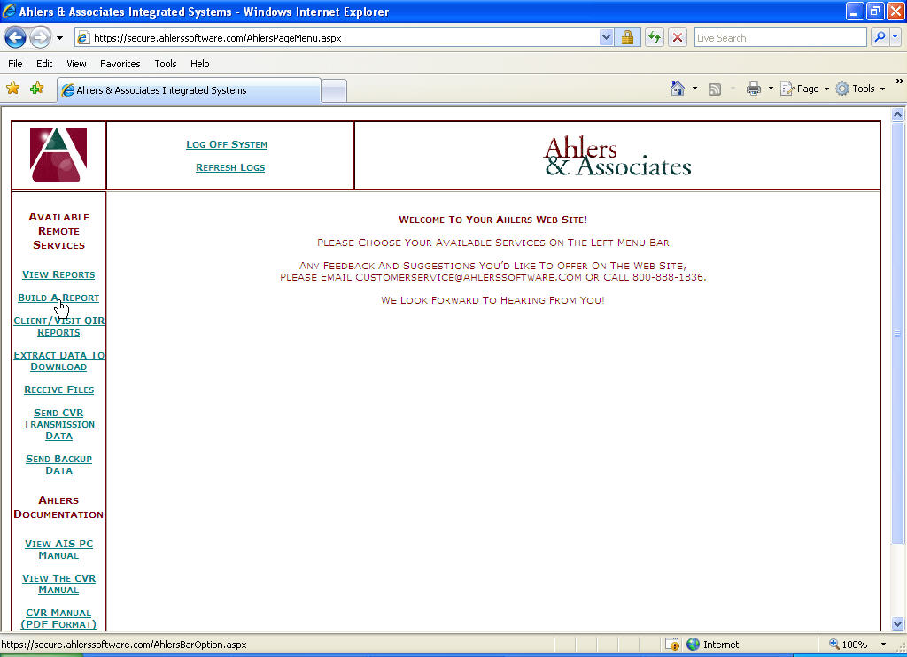

- On the first Build A Report screen, choose your agency from the “Select an Agency” drop-down menu (unless it is already defaulted to your agency).

- To obtain the unduplicated female client count for May 2018 to start:
First obtain the YTD total for April 2018, by entering ‘1/1/2018’ for the “From Date” and ‘4/30/2018’ for the “To Date” as shown above.
Then obtain the YTD total for May 2018, by entering ‘5/31/2018’ for the “To Date”.
To obtain, the YTD total for each of the months following May through December, you will need to enter the first day of the year, e.g., 1/1/2018, for the “From Date” and the last day of the month of interest for the “To Date.” To obtain the YTD running total for each of the months January through March of 2019, you will need to enter the first day of the new year, i.e., 1/1/2019 for the “From Date,” which will in effect restart the YTD running totals of unduplicated clients tested and served.

*** Note: A table of monthly YTD running total periods is provided at the end of this document. ***
- For the “Option Down,” select “STD Services.”

- For the “Option Across,” select “Age Breakdown.”

- Click on “Continue to Build a Report.”

- Locate the selection options on the upper right-hand side of the next Build A Report web page.

- Click on “Female Only.”

Note: please be sure to select “FEMALE ONLY” each time you change the time period.

DO NOT REQUEST UNDUPLICATED AGE ON LAST VISIT.

- Scroll to the bottom of the page to the “Unduplicated Totals” section.

The third row provides the total number of unduplicated female clients served YTD by age group.
The second to last row provides the unduplicated number of female clients tested for Chlamydia YTD by age group.

- To calculate the total served YTD and the total tested YTD for the age group 15-24, add together the corresponding counts for the smaller age groups: 15-17, 18-19, and 20-24.

- Record both of these unduplicated female client YTD totals for the month specified in “To Date” either in the provided data collection tool or elsewhere of your choice.

*** Note: if you record the client YTD totals for April 2018 and each of the subsequent project months in the provided Excel tool, the calculations following in steps 16 and 17 and detailed in the example for May 2018 will be automated for you. ***

- To isolate the unduplicated counts of female clients aged 15-24 who were newly served and were newly tested for Chlamydia in the current month, subtract the previous month’s unduplicated client YTD totals from the current month’s unduplicated client YTD totals.

- To calculate the percentage of female clients aged 15-24 tested for Chlamydia, divide the unduplicated total tested by the unduplicated total served.

Detailed example of calculations for May 2018:
To obtain the unduplicated client count of females aged 15-24 served for May 2018 (A), subtract April’s (previous month) YTD total of client served for 1/1/2018 – 4/30/2018 from May’s (current month) YTD total of clients served for 1/1/2018 – 5/31/2018.
To obtain the unduplicated client count of females aged 15-24 newly tested for Chlamydia for May 2018 (B), subtract April’s (previous month) YTD total of clients tested for 1/1/2018 – 4/30/2018 from May’s (current month) YTD total of clients tested for 1/1/2018 – 5/31/2018.

Divide the count of clients tested (A) during May by the count of clients served during May (B) and multiply the result by 100 to get the percentage tested for Chlamydia during May.

Total female clients aged 15-24 served YTD 1/1/18 – 5/31/2018: 50
Total female clients aged 15-24 served YTD 1/1/18 – 4/30/2018: 35
Total female clients aged 15-24 newly served 5/1/2018-5/31/2018: 25

Total female clients aged 15=24 tested YTD 1/1/18 – 5/31/2018: 20
Total female clients aged 15-24 served YTD 1/1/18 – 4/30/2018: 10
Total female clients aged 15-24 newly served 5/1/2018-5/31/2018: 10

Percentage female clients newly tested 5/1/2018 – 5/31/18: 10 / 25 * 100 = 40.0%

- To continue using Ahlers’ website, select “Return to Report Options” at the top of the screen.

- When you are finished, log off of Ahlers’ web site.

Table of Corresponding Previous and Current Months’ YTD Total Period Specifications
Month for Which Unduplicated Count Is Needed | Previous Month’s YTD Total Period | Current Month’s YTD Total Period
May 2018 | 1/1/2018 – 4/30/2018 | 1/1/2018 – 5/31/2018
June 2018 | 1/1/2018 – 5/31/2018 | 1/1/2018 – 6/30/2018
July 2018 | 1/1/2018 – 6/30/2018 | 1/1/2018 – 7/31/2018
August 2018 | 1/1/2018 – 7/31/2018 | 1/1/2018 – 8/31/2018
September 2018 | 1/1/2018 – 8/31/2018 | 1/1/2018 – 9/30/2018
October 2018 | 1/1/2018 – 9/30/2018 | 1/1/2018 – 10/31/2018
November 2018 | 1/1/2018 – 10/31/2018 | 1/1/2018 – 11/30/2018
December 2018 | 1/1/2018 – 11/30/2018 | 1/1/2018 – 12/31/2018
January 2019 | 1/1/2019 – 1/31/2019 | 1/1/2019 – 1/31/2019
February 2019 | 1/1/2019 – 1/31/2019 | 2/1/2019 – 2/28/2019
March 2019 | 1/1/2019 – 2/28/2019 | 1/1/2019 – 3/31/2019
****Note the change in calendar year and duration beginning in January 2019.****

